**ROC curve for the individual classes**

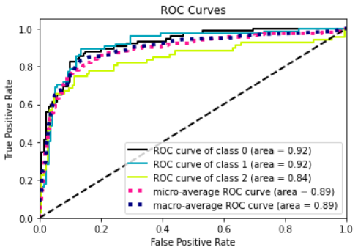

**Evaluation metrics**

|  |  |  |
| --- | --- | --- |
| **MODEL** | **TRAINING** | **VALIDATION** |
| **Loss** | 0.3823 | 0.8385 |
| **Accuracy** | 90.62 | 79.85 |
| **Precision** | 89.74 | 79.64 |
| **Recall** | 88.76 | 77 |
| **AUC** | 0.9610 | 0.8933 |

**ARCHITECTURE DIAGRAM**

